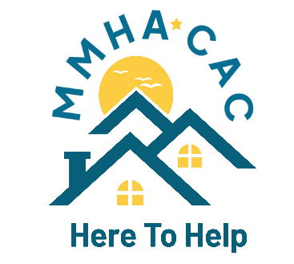 | Miami Metropolitan Housing Authority  Miami County Community Action Council  1695 Troy-Sidney Road, Troy OH 45373-9794 | P: (937) 335-7921  F: (937) 339-8905  www.miamimha.org  www.miamicac.org

Landlord Incentive and Security Deposit Program Offered By MMHA

Beginning March 21, 2022, Miami County landlords may receive a $750 incentive payment for units made available to families with a Housing Choice Voucher. This payment is authorized by submitting an executed Section 8 Housing Assistance Payment (HAP) contract to MMHA “With the increased need for affordable housing in the county, this new signing bonus program will provide landlords a strong incentive to sign a Housing Assistance Payment contract, opening the door to increased housing stability in our communities,” said MMHA Executive Director Keith GunderKline. “We’re hoping to attract new landlords to participate in the program so that they can see first-hand the benefits of renting to our qualified families.” Any units from a newly participating landlord are eligible for incentive payments, as are landlords currently participating in the program who lease new units to new voucher holders searching for a unit. We also will offer $750 payment on behalf of the tenant for security deposit.
MMHA currently has more than 75 families with vouchers who are finding it difficult to locate available, suitable housing in the county. An increasing number have been forced to let their voucher expire due to the challenge in finding vacant units that meet the basic Voucher Program requirements. Participating landlords are guaranteed prompt payment of the monthly rent amount needed to supplement the tenant’s rent share - which is based on a percentage of their income.
The incentive payments will be available on a first-come, first-served basis until the current $20,000 of designated incentive funds are exhausted. To be eligible, a landlord must make available a new unit to lease to a new voucher holder. If successful, a similar incentive program may be made available in the future. More information can be found on the MMHA website at miamimha.org, or by calling (937) 335-7921.

